**Kurtosis and Skewness Range Report for Placement Data**

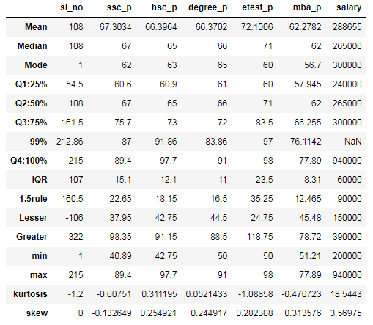

**Kurtosis and Skewness Range for ssc_p**

**kurtosis= -0.60751**

Above value falls under <3 and pink color in graph. we can say it comes under platykurtic.

"platykurtic" refers to a statistical distribution where the value of excess kurtosis is negative. A platykurtic distribution would, therefore, have thinner tails than a normal distribution

**Skewness= 0.132649**

We could see skewness value is positive. so that we can say Mode is high and also it comes under Mode>Med>Mean

**Kurtosis and Skewness Range for hsc_p**

**kurtosis= 0.311195**

Above value falls under =3 and black color in graph. we can say it comes under mesokurtic.

Mesokurtic is a statistical term used to describe the outlier characteristic of a probability distribution in which extreme events (or data that are rare) is close to zero. A mesokurtic distribution has a similar extreme value character as a normal distribution.

**Skewness= 0.254921**

We could see skewness value is positive. so that we can say Mode is high and also it comes under Mode>Med>Mean

**Kurtosis and Skewness Range for degree_p**

**kurtosis=** 0.0521433

Above value falls under =3 and black color in graph. we can say it comes under mesokurtic.

Mesokurtic is a statistical term used to describe the outlier characteristic of a probability distribution in which extreme events (or data that are rare) is close to zero. A mesokurtic distribution has a similar extreme value character as a normal distribution.

**Skewness=** 0.244917

We could see skewness value is positive. so that we can say Mode is high and also it comes under Mode>Med>Mean

**Kurtosis and Skewness Range for etest_p**

**kurtosis=** -1.08858

Above value falls under <3 and pink color in graph. we can say it comes under platykurtic.

"platykurtic" refers to a statistical distribution where the value of excess kurtosis is negative. A platykurtic distribution would, therefore, have thinner tails than a normal distribution

**Skewness=** 0.282308

We could see skewness value is positive. so that we can say Mode is high and also it comes under Mode>Med>Mean

**Kurtosis and Skewness Range for mba_p**

**kurtosis=** -0.470723

Above value falls under <3 and pink color in graph. we can say it comes under platykurtic.

"platykurtic" refers to a statistical distribution where the value of excess kurtosis is negative. A platykurtic distribution would, therefore, have thinner tails than a normal distribution

**Skewness=** 0.313576

We could see skewness value is positive. so that we can say Mode is high and also it comes under Mode>Med>Mean

**Kurtosis and Skewness Range for salary**

**kurtosis=** 18.5443

Above value falls under >3 and blue color in graph. we can say it comes under leptokurtic.

A leptokurtic distribution means that the investor can experience broader fluctuations (e.g., three or more standard deviations from the mean) resulting in greater potential for extremely low or high returns.

**Skewness=** 3.56975

We could see skewness value is positive. so that we can say Mode is high and also it comes under Mode>Med>Mean